1. A design pattern is:

* Algorithm used in object-oriented programming
* Data structure used in object-oriented programming
* **Solution to a common problem in object-oriented programming**
* Blueprint for a particular kind of class

1. What Design Pattern is used in the following UML diagram?

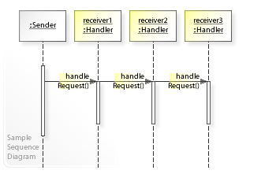

* Command
* **Chain of Responsibility**
* Observer
* Strategy

1. "Invoker", "Request", "Receiver" are the keywords specific to the _____________ design pattern.

* Bridge
* Observer
* Strategy
* **Command**

1. Identify a design pattern in the following real world UML example

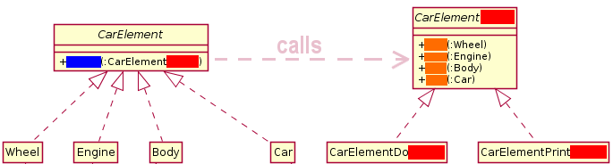

* **Visitor**
* Strategy
* Observer
* Command

1. Chain of Responsibility: Fill in the most appropriate keyword

*[Chain of Responsibility] The ____________________ handles requests it responsible for, otherwise forwards requests to successor*

* Request
* Client
* Handler
* **Concrete Handler**

1. What is true for Chain of Responsibility's Client?

*Decorators change the behavior of their components by adding new functionality to the component. When this adding of the functionality can happen?*

* Client initiates a request to one of several objects and it specifies which one of them should hande it.
* **Client initiates a request to one of several objects and it doesn’t specify which one of them should handle it.**
* Client initiates a request and passes it to more objects and it specifies which one of them should handle it.
* None of the options